Phase 3 – Project Design Phase

1. System Architecture
PocketSmart AI is an intelligent, modular platform that integrates a lightweight Python web backend with Google's Gemini 1.5 Flash Pro, a multimodal AI model that processes text, numbers and images. The architecture diagram supplied with the project is shown below. It depicts the request path from the user through the content delivery and API layers to the orchestration logic, which sends the budget, preferences and context to Gemini as a prompt, receives curated recommendations, and consults external e-commerce platforms for product details.
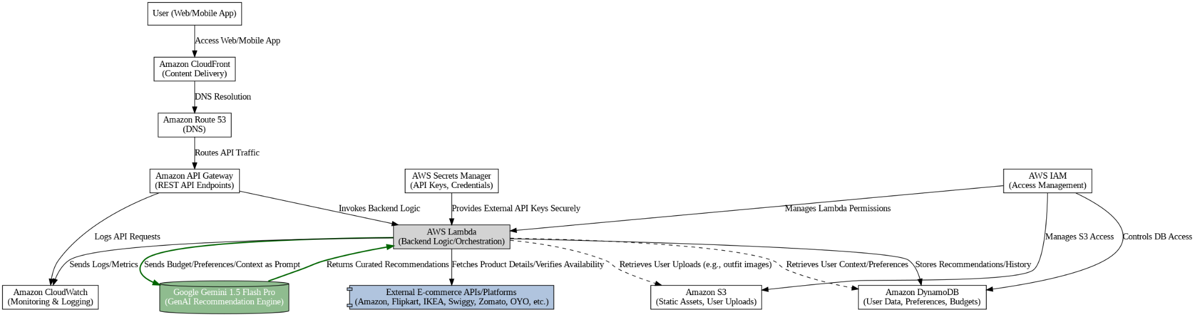
Figure 1: System Architecture (as provided in the project)
Note. The diagram shows a cloud deployment view (CloudFront, Route 53, API Gateway, Lambda, S3, DynamoDB, Secrets Manager, IAM, CloudWatch). The implementation documented in Phase 5 is a FastAPI application (app.py) with the Gemini SDK integrated directly.

2. Components Definition

Frontend UI
Purpose: collect budgets, preferences and images and present recommendations. Responsibility: HTML/CSS/JavaScript pages rendered through Jinja2 (index, login, register, dashboard, home_planner, party_planner, jewelry_planner, history). Interaction: submits forms to the FastAPI routes and displays the returned recommendations in card-like layouts.

FastAPI Backend
Purpose: central request handler. Responsibility: routing, input models, CORS configuration, static file mounting, authentication and session management. Interaction: receives requests from the UI, calls the recommendation functions, and returns rendered pages or JSON.

Gemini AI Layer
Purpose: generate recommendations. Responsibility: builds prompts from user input, calls Gemini 1.5 Flash Pro, and extracts the JSON payload from the model response (extract_json_from_response). Interaction: called by the planner functions; for jewelry it also receives the uploaded outfit image.

Shopping Link Generator
Purpose: connect recommendations to shopping platforms. Responsibility: for each item that has search terms, builds search URLs for Amazon, Flipkart, IKEA, Myntra and Ajio using urllib.parse.quote_plus. Interaction: runs after the Gemini response is parsed and adds a shopping_links object to each item.

Authentication & Session Manager
Purpose: protect the planners. Responsibility: password hashing, JWT creation, cookie handling, active session tracking, token blacklisting and expired-session cleanup. Interaction: protected routes depend on get_current_active_user.

Recommendation Store
Purpose: keep each user's generated recommendations. Responsibility: stores an ID, timestamp, recommendation type, input summary and full result per recommendation. Interaction: read by the /history and recommendation-details routes.

3. Data Flow
- The user submits a planner form (and optionally an image) from the browser.
- The FastAPI route validates the input using Pydantic models and confirms the user's session.
- The planner function builds a structured prompt containing the budget and preferences.
- The prompt (and image, for jewelry) is sent to Gemini 1.5 Flash Pro.
- The JSON in the model response is extracted, and shopping links are added for every item.
- The result is saved in the user's recommendation history and returned to the UI.
- The UI renders the budget breakdown, item details and shopping links.
[INSERT DATA FLOW DIAGRAM HERE]
Figure 2: Data Flow Diagram (diagram not provided in the project file)

4. User Flow
- Open the home page and register a new account, or log in.
- Land on the dashboard showing recent recommendations and saved queries.
- Choose a planner: Home, Party or Jewelry.
- Fill in the planner form (optionally upload an outfit image for jewelry) and submit.
- View the AI-generated recommendations with prices and shopping links.
- Revisit earlier results from the history page, then log out.
[INSERT USER FLOW DIAGRAM HERE]
Figure 3: User Flow (diagram not provided in the project file)

5. Database Design
The provided project does not include a database schema, database connection code or an ER diagram. The code screenshots show user records, active sessions, blacklisted tokens and per-user recommendations being handled through in-memory structures (users_db, active_sessions, blacklisted_tokens, user_recommendations). Only uploaded images are written to disk (static/uploads). The architecture diagram lists Amazon DynamoDB as a data store in the cloud view, but no corresponding implementation is documented.
Recommendation records contain the following fields, as read by the recommendation-details route:
Field | Description
id | Unique identifier of the recommendation
timestamp | Time the recommendation was created
recommendation_type | Planner type (home, party or jewelry)
input_summary | Summary of the user input used for the request
full_result | Complete AI-generated result
[ER DIAGRAM NOT APPLICABLE: NO DATABASE SCHEMA PROVIDED]
Figure 4: Entity-Relationship Diagram (not available in the project file)

6. Module Design
Module | Design summary
Home Interior Planner | Inputs: total budget, number of lights/fans/furniture/dining tables, room flags, additional requirements. Output: budget breakdown by category, calculation table, remaining budget and additional suggestions, in INR for the Indian market.
Party Planner | Inputs: budget, guest count, event type, venue details. Output: catering, venue and decoration options, categorized by the type of event.
Jewelry Planner | Inputs: budget, occasion, style preferences, optional outfit image. Output: style-matched jewelry options.
Authentication & Sessions | Register, login, logout, token issue, session information and session data update.
Recommendations & History | Stores results, lists past queries and returns details of one recommendation.
Dashboard & Home | Landing page with testimonials and footer; dashboard with recent recommendations and saved queries.

7. Security Design
- Password hashing: bcrypt through passlib CryptContext.
- Authentication: OAuth2 password flow; the /token endpoint returns a signed JWT with an expiry time for valid credentials and HTTP 401 for invalid credentials.
- Cookie handling: the access token is set as an HttpOnly cookie with samesite="lax" and a maximum age.
- Session control: one active session per user; a previous token is blacklisted on a new login; sessions inactive for more than 30 minutes are removed by a background task.
- Access control: planner, dashboard, history and session routes depend on get_current_active_user.
- Input validation: Pydantic models (including EmailStr) validate registration and planner input.
- Secret management: the Gemini API key is read from environment variables (GOOGLE_API_KEY or GEMINI_API_KEY) loaded from .env.

